Defense Science Vol. 9. No. 3. April 2024 DOI: 10.61790/vt.2024..…………

Official sample article for publication in the journal Védelem Tudomány

Hivatalos minta cikk a Védelem Tudomány folyóiratban történő megjelentetéshez

|  |  |  |
| --- | --- | --- |
| Iván Kiss  author  Organization, position  Email:  ORCID: | | |
| István Nagy  co-author  Organization, position  Email:  ORCID: | | Zoltán Virág  co-author  Organization, position  Email:  ORCID: |
| Absztrakt: | Abstract: | |
| The abstract in Hungarian is a 250–300 word brief summary that provides an overview of the article's content, conclusions, and applicability of its findings.  Spacing: 6 pt before the first paragraph and after the last line. Line spacing: single. Font: Garamond, size 10. Alignment: justified. | Following this, the English version of the abstract, identical in content to the Hungarian version, is presented.  Spacing: 6 pt before the first paragraph and after the last line. Line spacing: single. Font: Garamond, size 10. Alignment: justified. | |
| Kulcsszavak: hivatalos, minta, cikk, Védelem Tudomány, megjelentetés | Keywords: official, sample, article, Védelem Tudomány, publication | |

1. INTRODUCTION

A preliminary introduction of the topic chosen by the author(s), with a maximum length of 1,500–2,000 characters.

Spacing: 12 pt before the first paragraph and after the last line. Line spacing: single. Font: Garamond, size 12. Alignment: justified.

2. MAIN BODY (Title to be adjusted according to the topic; maximum one line!)

A detailed discussion of the topic chosen by the author(s), with a length of 30,000–35,000 characters. The main issues can be divided into subsections as follows:

* 1. **Subsection – First Topic**

Text related to the main content, is divided into subsections.

* 1. **Subsection – Second Topic**

Text related to the subsection.

Subsections can be divided into one additional level (e.g., 1.1.1).

Spacing: 12 pt before the first paragraph and after the last line. Line spacing: single. Font: Garamond, size 12. Alignment: justified. Subheadings should be bold; second-level subheadings should be italicized (e.g., 1.1.1 – First Topic).

Figures, tables, diagrams, and other objects should be embedded in the text, translated into the article's base language if necessary, and numbered with captions, such as:



Figure 1: The logo of the Scientific Council for Disaster Management (Source: see [2])

Or:

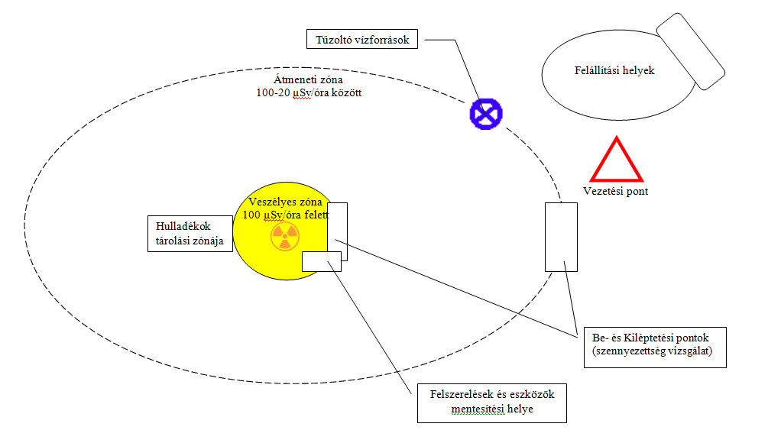

Diagram 1**:** General site layout by first responders (created by the authors)

Or:

Example for tables:

|  |  |  |
| --- | --- | --- |
| N. | Option 1 | Option 2 |
| 1. | Choice 1 | Choice 2 |
| 2. | Start menü | Watershed |
| 3. | 1 247 679 | 1. 2 |

Table 1: Sample Table (created by the authors)

3. CONCLUSION

A summary of the findings and applicability of the research topic chosen by the author(s), with a maximum length of 5,000 characters.

Spacing: 12 pt before the first paragraph and after the last line. Line spacing: single. Font: Garamond, size 12. Alignment: justified.

4. APPENDICES

Supporting content that does not fit directly into the main text, with a maximum length of 20,000 characters or eight pages.

Spacing: 12 pt before the first paragraph and after the last line. Line spacing: single. Font: Garamond, size 12. Alignment: justified.

4. REFERENCES

[1] 6/2016. (VI. 24.) BM OKF utasítása Tűzoltás-taktikai Szabályzat és a Műszaki Mentési Szabályzat kiadásáról

[2] Manual for First Responders to a Radiological Emergency, IAEA EPR-First Responders, Austria 2006 [Online]. Elérhetőség: https://www.iaea.org/publications/7606/manual-for-first-responders-to-a-radiological-emergency (2021. 12. 03.)

[3] Átfogó Veszélyhelyzet-kezelési és Intézkedési Terv, (ÁVIT) I. modul: Általános kötet, MVM Paksi Atomerőmű Zrt. Verziószám: 9.3, Paks, (2016.02.04.)

**GENERAL INFORMATION ABOUT CITATIONS AND ARTICLE SUBMISSION:**

1. Preparing References:

Citations within the text should follow IEEE style guidelines and the Defense Science reference template. Authors should provide detailed references, including page numbers (e.g., [3, p. 49]), and specify download dates for online resources.

<http://journals.ieeeauthorcenter.ieee.org/wp-content/uploads/sites/7/IEEE_Reference_Guide.pdf>

<https://journals.ieeeauthorcenter.ieee.org/your-role-in-article-production/ieee-editorial-style-manual/>

We ask all authors to, where possible, in addition to displaying the links, please also provide the exact page number of the referenced material (E.g.: [3, p. 49]), and when marking the electronic website or material, the exact date of the download should also be indicated in the case of references at the end of the contact section. E.g.:

Elérhetőség: <https://www.youtube.com/watch?v=4KZmx4kdBf0> (2024.06.11.)

2. Submitting Articles:

The article can be submitted in an MS Word doc or docx file after formatting byin accordance with the above requirements. The length cannot be less than 10,000 characters per article and cannot exceed 40,000 characters without attachments. When writing articles, jargon, and words from foreign languages without explanation should be avoided as much as possible. Unclear words or convenient abbreviations must be explained in a footnote and recorded in parentheses when they first appear.

For example:

"Besides the existence of crises and black swan events, the international community has increasingly begun to deal with theso-called extraordinary impact low probability events (HILP)."

The images and tables published in the article must always be referenced in the text. The editors consider objects unrelated to the written content to be errors. The quality of the displayed images, tables, and diagrams must not be objectionable (e.g. pixelated, blurred, poorly legible, made with too small characters). Otherwise the material must be modified, which may result in a loss of time. There is no requirement to submit images and figures separately. Still, during technical editing, assigning and sending them as attachements may be necessary, with the proviso that the minimum resolution of the images is 1024x768 pixels and the maximum resolution is 1920x1080 pixels. In the case of image attachments, we avoid using the text box. The picture, figure, or table should be an independent object inserted in the middle.

Using numbered footnotes in articles is permitted, primarily for explanation or addition. However, it is necessary to ensure that explanations longer than 1-2 sentences are incorporated into the body of the text.

The appendices must be included in the submitted doc, docx file after the bibliography, on a separate page after the page break, and the material must be submitted as such. The length of attachments can be a maximum of 20,000 characters or eight pages, the value of which is not included in the main text. In exceptional cases, such as long articles exceeding the maximum length, but with adequate content and scientific values, the editorial board may agree to the publication in two (more) installments. After the preparation of the article, the author attaches the author's declaration, duly filled in and signed, as an attachment to the material to be submitted. In the case of joint work by several authors, the authors ensure the preparation of the co-authorship statement, which is sent to the editors as an attached document at the same time as the submission of the article. By submitting the article, the author also declares that he accepts the application and use of Creative Commons NCU (Non-Commercial Use).

Read more: <https://creativecommons.org/licenses/by-nc/4.0/>

3. Peer Review:

Submitted materials are checked for plagiarism and double-anonymized proofread. Based on the results, the editors of Defense Science decide whether to publish, modify or reject the submitted articles. Due to the blind proofreading, we ask all authors to refrain from displaying personally identifiable content in the article. If the editors come across such recognizable content, they will send the material back for modification, which may result in significant publication delays. If plagiarism is suspected, the editorial board will initiate an investigation. Suppose the suspicion is confirmed, and the author has plagiarized or committed a significant ethical violation during the preparation and use of the material. In that case they will be immediately disqualified and may no longer publish in the issues of Defense Science.

4. Data protection, Copyright, and Ethics:

The author is responsible for the originality of the submitted material, the factuality of the data provided in it, the elaboration corresponding to the scientific level, the compliance with the formal and Hungarian spelling rules published in the author's guide, and the accuracy of the references. At the same time as the submission, the author declares that the submitted documents have not yet been published in another form/journal or proofread. In connection with the submission of the manuscript materials, the author accepts the data protection regulations of the Ministry of Science, the copyright statement, and the rules of the Scientific Ethics Code of the Hungarian Academy of Sciences[1].

5. Evaluation of submitted articles:

The primary goal of the Defense Science journal is to support the work of authors researching in the field of disaster prevention and to provide them with the possibility of publication at the highest possible level. During this activity, priority is given to authors who are doctoral students or whose training or admission requirement is the existence of the appropriate number of publications to complete their studies or obtain a degree. The editorial office of Védelem Tudomány also aims to raise the quality of the published content to the highest possible level, as well as the gradual, continuous development of the paper on a scientific level. To carry out these tasks efficiently, the Editorial Board reserves the right to evaluate the submitted materials for publication, to select the number of publications, or to reject the submitted material. In case of rejection, the editors decide to inform the author with or without reason.

1. <https://mta.hu/data/dokumentumok/hatteranyagok/tudomanyetikai_bizottsag/tudomanyetikai_kodex_kgy_20100504.pdf> (2023.11.21.)